Software Process:

A software process, also known as a software development process or software engineering process, is a set of activities, methods, practices, and transformations that people use to develop and maintain software and the associated products (such as documentation). It provides a structured framework for planning, structuring, and controlling the process of developing information systems.

Key Characteristics of Software Processes:

1. Systematic Approach: Software processes involve a systematic and organized set of activities to ensure the quality and reliability of the software being developed.

2. Iterative and Incremental: Many software development processes are iterative and incremental, meaning that they involve cycles of revisiting and refining the work as the project progresses.

3. Communication and Collaboration: Effective communication and collaboration among team members are crucial in a software process. This includes communication between developers, testers, and other stakeholders.

4. Documentation: Software processes typically require documentation at various stages to capture design decisions, requirements, and other important information.

Software Process Models:

A software process model is a simplified representation of a software process. It presents a specific order of phases or steps, each leading to the next, in the software development life cycle. Different process models have been developed to guide the processes involved in software development. Here are some commonly used software process models:

1. Waterfall Model:

- Description: In the waterfall model, the development process is divided into distinct phases, and each phase must be completed before the next one begins.

- Advantages: Simple and easy to understand, well-suited for small projects with well-defined requirements.

- Disadvantages: Lack of flexibility, difficulty in accommodating changes, and potential for a long development cycle.

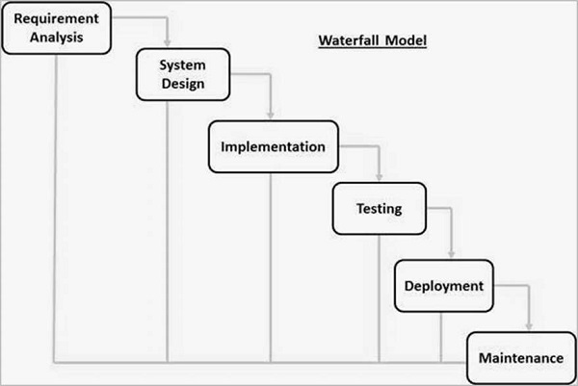

2. Iterative Model:

- Description: The iterative model involves repeating cycles, with each iteration refining the software based on feedback from the previous iteration.

- Advantages: Allows for flexibility and adaptation to changing requirements, early delivery of a partial product.

- Disadvantages: Can be time-consuming and may lead to scope creep if not managed properly.

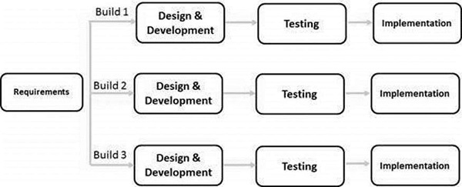

3. Incremental Model:

- Description: Similar to the iterative model, the incremental model divides the software into smaller, manageable parts called increments, each of which is developed separately.

- Advantages: Easier to test and debug, partial implementation can be delivered earlier.

- Disadvantages: Requires careful planning to identify increments, and integration may be challenging.

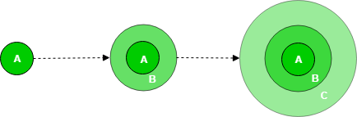

4. Spiral Model:

- Description: The spiral model combines elements of the waterfall model with iterative development and incorporates risk assessment at each iteration.

- Advantages: Emphasizes risk analysis, accommodates changes during the development process.

- Disadvantages: Can be complex and may require significant expertise to manage.

5. Agile Model:

- Description: Agile is an iterative and incremental approach that emphasizes flexibility, collaboration, and customer feedback.

- Advantages: Adaptable to changing requirements, promotes customer satisfaction through continuous delivery of small, functional pieces.

- Disadvantages: May require a high level of collaboration and communication, and can be challenging to manage for large projects.

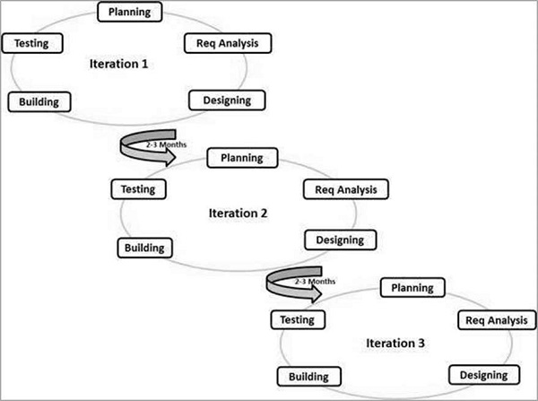

Staff Selection 9/12

Staff selection is a crucial aspect of project success, directly influencing the quality of the product. The following factors play a vital role in the selection procedure:

**Application Domain Experience:**

* Candidates with relevant industry experience bring insights that enhance the project's alignment with industry standards.
* Knowledge of the application domain ensures a more comprehensive understanding of project requirements and potential challenges.

**Platform Experience:**

* Familiarity with specific platforms can lead to more efficient development, reducing the learning curve for new hires.
* Platform expertise contributes to streamlined processes and optimized product performance.

**Programming Language Experience:**

* Proficiency in the project's chosen programming languages ensures smoother development and reduces the likelihood of coding errors.
* Matching language skills with project requirements enhances code quality and maintainability.

**Problem-Solving Ability:**

* A candidate's problem-solving skills directly impact the project's ability to overcome challenges and innovate.
* Strong problem-solving abilities contribute to effective troubleshooting and the creation of robust solutions.

**Educational Background:**

* Relevant educational qualifications provide a foundation of theoretical knowledge, complementing practical skills.
* Certain roles may require specific academic backgrounds for a better grasp of advanced concepts.

**Communication Ability:**

* Effective communication fosters collaboration, reducing misunderstandings and enhancing team productivity.
* Clear communication is crucial for conveying project goals, requirements, and updates to team members and stakeholders.

**Adaptability:**

* Projects often evolve, and an adaptable team can navigate changes more effectively.
* Candidates who demonstrate adaptability can quickly learn and integrate new technologies or methodologies.

**Personality:**

* Team dynamics greatly influence project success; selecting individuals with compatible personalities fosters a positive working environment.
* A collaborative and positive personality contributes to effective teamwork and can mitigate conflicts.

2 Marks

1. Analyze some problems with software projects

Some common problems with software projects include poor communication, unrealistic expectations, inadequate testing, and scope creep¹.

2. Write down the steps in cost benefit analysis

The steps in cost-benefit analysis are as follows: identify the costs and benefits of the project, assign a monetary value to each cost and benefit, calculate the net present value of the project, and compare the net present value to the project's initial investment³⁴.

3.Justify and define RAD is incremental model

Rapid Application Development (RAD) is an incremental model that emphasizes rapid prototyping and iterative development. It is designed to reduce development time and increase flexibility by involving users in the development process¹.

4. Distinguish between Bottom-up and Top-Down estimate

Bottom-up estimating is a technique that involves estimating the costs or duration of projects and parts of a project at a very granular level, such as work packages or activities. Top-down estimating, on the other hand, involves estimating the costs or duration of a project based on high-level information, such as historical data or expert judgment¹².

5. Interpret dangle in an activity network. Give an example

A dangle in an activity network is an activity that has no successor. For example, if an activity is scheduled to start before its predecessor has finished, it will create a dangle. This can cause delays in the project schedule and should be avoided¹.

6. Illustrate the framework for dealing with the risk analysis

The framework for dealing with risk analysis includes the following steps: identify the risks, assess the risks, develop a risk management plan, implement the plan, and monitor and control the risks¹.

7. Draw the project control cycle model

The project control cycle model consists of four stages: planning, execution, monitoring and control, and closing. During the planning stage, the project scope, objectives, and deliverables are defined. During the execution stage, the project plan is put into action. During the monitoring and control stage, progress is tracked and corrective actions are taken as needed. Finally, during the closing stage, the project is completed and evaluated¹.

8. Classify the methods for earned value analysis

The methods for earned value analysis can be classified into three categories: planned value (PV), actual cost (AC), and earned value (EV). PV is the budgeted cost of the work scheduled to be done. AC is the actual cost of the work that has been done. EV is the value of the work that has been completed according to the project plan¹.

9. Write down the process of identifying the right persons for the job

The process of identifying the right persons for the job involves the following steps: define the job requirements, identify potential candidates, screen the candidates, interview the candidates, and select the best candidate¹.

10. What are the factors to be considered in the Oldham - Hackman job characteristic model?

The Oldham-Hackman job characteristic model identifies five factors that contribute to job satisfaction: skill variety, task identity, task significance, autonomy, and feedback¹.